CAS PY 106

Lecture note 28

1. Concave mirrors and a pig? Oh, Wilbur!
2. 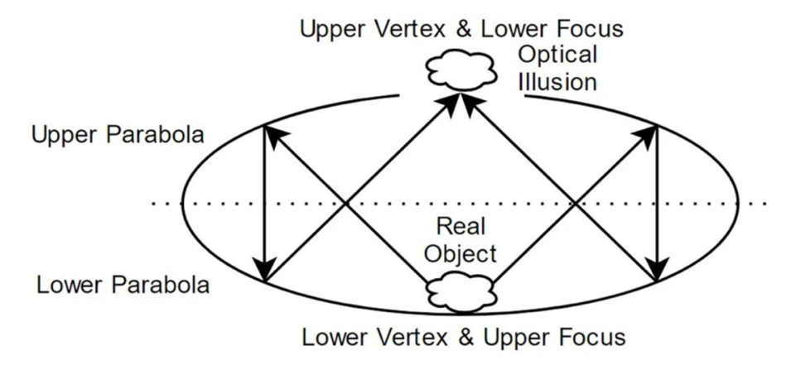
3. The Law of Reflection
4. 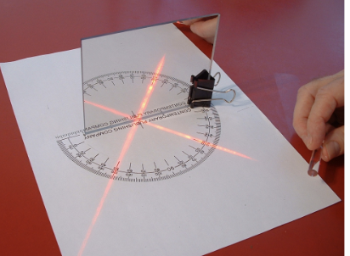
5. 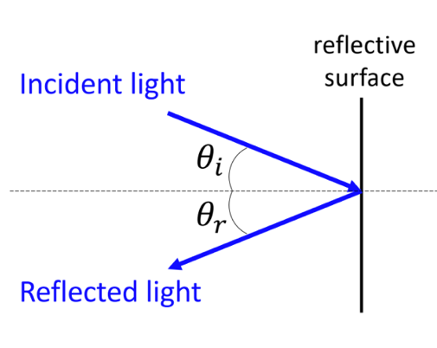
6. Angle of incidence = angle of reflection
7. Planar (flat) mirror
8. 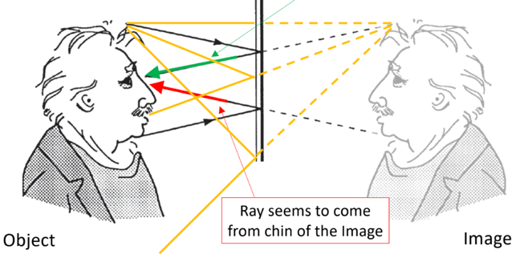
9. Also valid, but these don’t converge on your eyes
10. The Law of Reflection for Curved Surfaces
11. 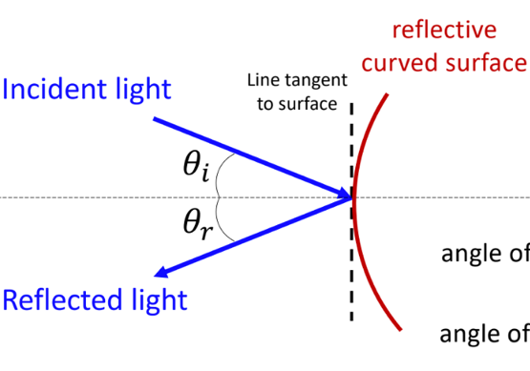
12. Curved mirror
13. 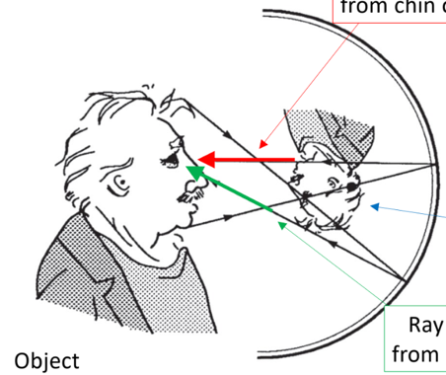
14. Spherical mirrors
15. A spherical mirror is defined by a few points in space:

* C, the center of curvature, is the center of the sphere the mirror is made from
* R is that sphere’s radius
* The focal point F is the point where parallel rays meet (concave mirror) or appear to diverge from (convex mirror)

1. 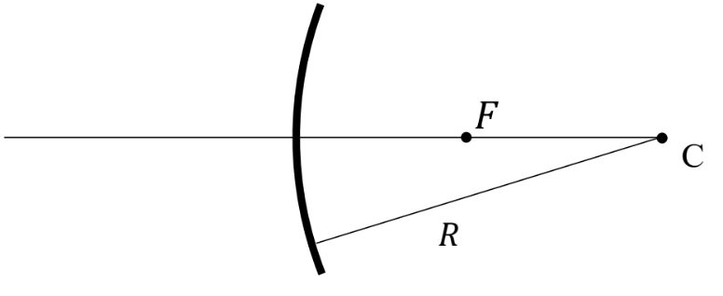
2. 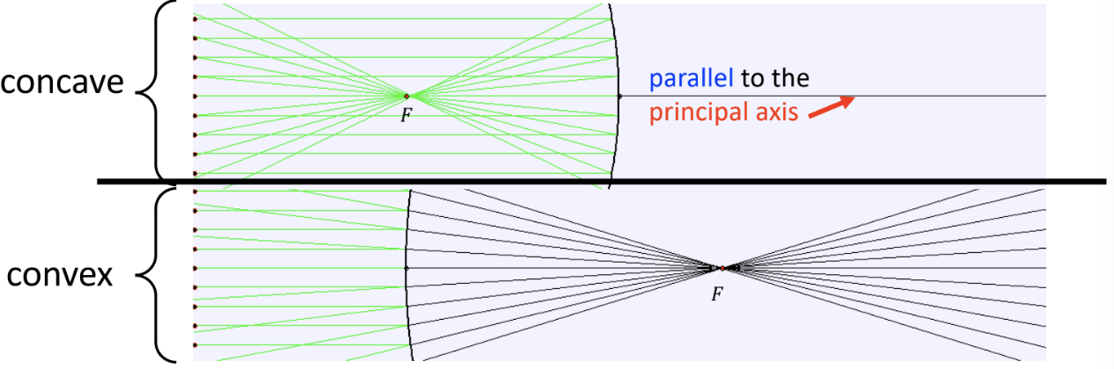
3. Convex mirror ray diagram
4. Some rays are easier to draw than others, because we know exactly where they go when they reflect from the mirror
5. The parallel ray goes from tip of the object horizontally to the mirror; reflecting off the mirror and traveling away from the focal point
6. 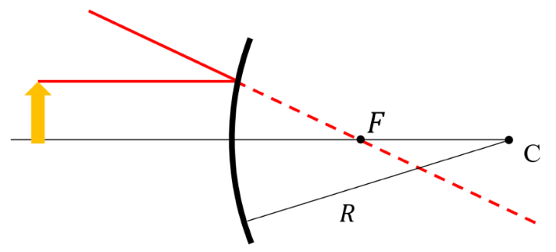
7. The middle ray goes from tip of the object to the middle of the mirror
8. The angle between the incident ray and the principal axis the same as that between the reflected ray and the principle axis
9. 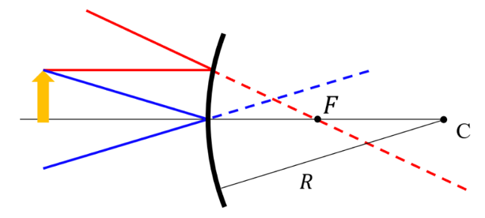
10. Two rays are enough to locate the tip of the image, but we can add one other to check
11. The final ray goes from the tip of the object toward the center of curvature, reflecting off at a 90 degree angle
12. All three reflected rays meet at the tip of the image
13. 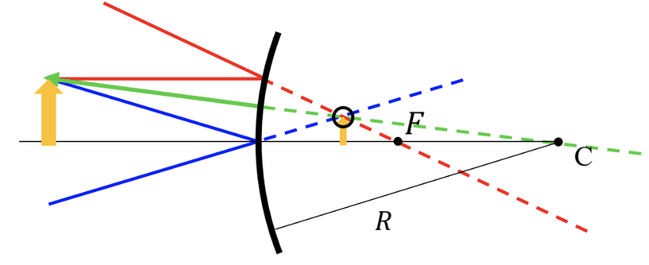
14. The image is virtual
15. The image is upright since magnification is m > 0 (positive) m = hi/h0
16. The image is smaller than the object since magnitude of magnification |m| < 1
17. 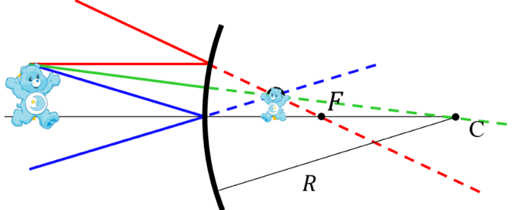
18. Mirror equation
19. Magnification:

m = hi/ho = -di/do

m > 0, image upright

m < 0, image inverted

|m| < 1 image is smaller than object

|m| > 1 image is larger than object

1. Convex mirrors: f < 0

Concave mirrors: f > 0

Focal length, f, is related to radius of curvature:

F = +R/2 for a concave mirror

F = -R/2 for a convex mirror

F = infinite for a plane mirror

1. Images formed by mirrors can be determined quantitatively with the mirror equation:

1/f = 1/d0 + 1/di

1. 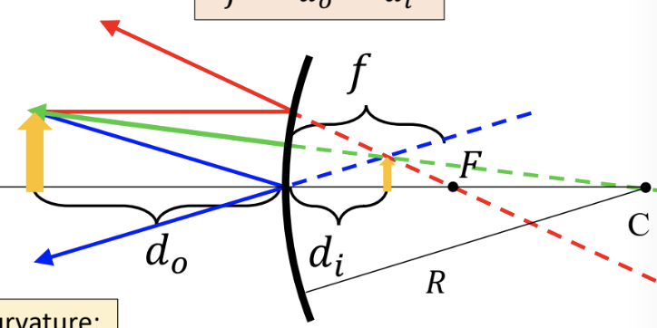
2. d is positive if it is in front of the mirror (e.g., d0 in this picture)

d is negative if it’s behind the mirror (di in this picture)

1. Spherical mirror example
2. The magnification of a particular concave mirror is m = -0.5 and the focal length is f = +0.5m. What is the object distance?
3. 